
Broadening Horizons 2 – Élargir les Horizons 2
Colloquium for a pluridisciplinary approach of
ancient landscapes studies
the 18th and 19th of June 2007 at Lyon, Maison de l’Orient et de la Méditerranée

Call for communications
1st circular
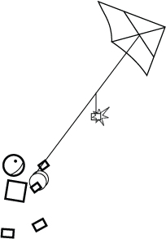

Over recent decades increasing research has been done on past archaeological and physical landscapes, leading to an expanding number of related disciplines and sub-disciplines. The use of field and aerial survey techniques, the investigation of various historical sources as well as the study of archaeological arte- and ecofacts are but some of the means available for assessing and reconstructing these changing environments. The International colloquium "Broadening Horizons", the first conference of which took place at the Ghent University (Belgium) on February 27 and 28, 2006, brought together young researchers in geography, archaeology and geomorphology who were actively studying past landscapes within the Mediterranean region and the Near East. Interdisciplinary research favor a systematical approach of landscape archaeology, a complex research theme placed at the frontier of human and environmental sciences. With over 120 participants from 9 different countries, the first edition was certainly a success.


We decided to organize a second colloquium, to be held at Lyon, at Maison de l’Orient et de la Méditerranée in France, the 18th and 19th of June 2007. In the same way of the first "Broadening Horizons", the main objective is the promotion of the young researchers (Ph.D. and post-doctorate level) communications. Two keynote speakers are also invited in order to present a communication about them of their own choice. This year, we have invited Eric Fouache (geoarchaeologist, professor at the University Paris XII) and Hartmut Kühne (archaeologist, professor at the Free University of Berlin).


We ask all young researchers interested to send us before the 30th of March an abstract in english or french of 300 words of their suggestion of oral or poster communication. Subjects which only present excavation results, site-specific artifact studies or environmental science studies based solely on a single site are not eligible.

Themes
Exploitation of environment

Landscape dynamics
Landscape reconstructions
Settlement patterns and networks
Workshop : Map and GIS in landscape archaeology studies

